**Regulation of Light Absorption for Gardening**

**OVERVIEW**

It is a system which measures the light near the plants and records the values. It then monitors the intensity of light by oning the led when the measured intensity is low and led goes off when the intensity of light is high.

**THINGS USED**

1. Bolt Iot Wi-Fi Module
2. USB Cable
3. Led
4. LRD(Light Sensor)
5. 330K Resistor
6. 100K Resistor
7. Connecting Wires

**STORY**

**INTRODUCTION**

IoT allows devices to be controlled remotely across the internet, thus it created opportunities to directly connect & integrate the physical world to the computer-based systems using sensors and internet. The interconnection of these multiple embedded devices will be resulting in automation in nearly all fields and also enabling advanced applications. This is resulting in improved accuracy, efficiency and economic benefit with reduced human intervention. It encompasses technologies such as smart grids, smart homes, intelligent transportation and smart cities.

Bolt is an Internet of Things Platform made for Machine Learning. Bolt IoT platform gives you the capability to control your devices and collect data from IoT devices safely and securely no matter where you are. Get actionable insights by deploying machine learning algorithms with just a few clicks to detect anomalies as well as predict sensor values.

**THEORY**

First we have to insert one lead of the LDR into the Bolt Module's 3v3 Pin.

Next we have to insert other lead of the LDR into the A0 pin

After that insert other lead of the LDR into the A0 pin

Later insert the other leg of the resistor also into the A0 pin

With this we will be effectively be able measuring the voltage across the 10k Ohm Resistor

Now to control the led we need to follow the steps

Go to cloud.boltiot.com and create a new product. While creating the product, choose product type as Output Device and interface type as GPIO. After creating the product, select the recently created product and then click on configure icon.

Next move to the code tab and write the following code to control the LED.

Once the complete code is written in the editor, give the file name as led control and in the drop-down select the file extension as html.

**CODE**

<html>

<head>

<title>Bolt IoT Platform</title>

<script type="text/javascript" src="https://cloud.boltiot.com/static/js/boltCommands.js"></script>

<script>

setKey('{{ApiKey}}','{{Name}}');

</script>

</head>

<body>

<center>

<button onclick="digitalWrite(0, 'HIGH');">ON</button>

<button onclick="digitalWrite(0, 'LOW');">OFF</button>

</center>

</body>

</html>

Light intensity - Python

from boltiot import Bolt

api_key = "XXXXXXXXXXXXXXXXXXXXXXXXXXXXXXXX"

device_id = "BOLTXXXXX"

mybolt = Bolt(api_key, device_id)

response = mybolt.digitalWrite('0', 'HIGH')

print (response)

**DEMONSTRATION**

Links

<https://youtu.be/UBxCFgVcBSw>

<https://youtu.be/K9U5IW-M6iA>

<https://youtu.be/coaepXy5ClI>

**SCHEMATIC**

**Light Measuring Device**

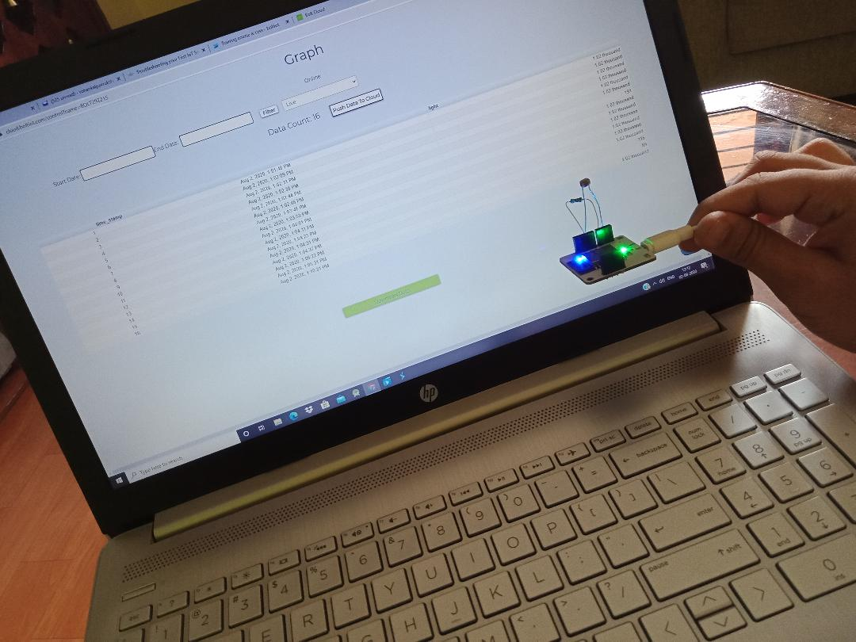

**Device Measurement’s output**

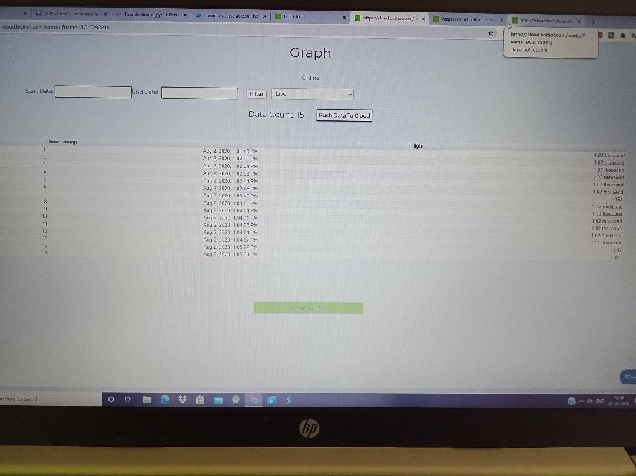

**LED Controller-ON**

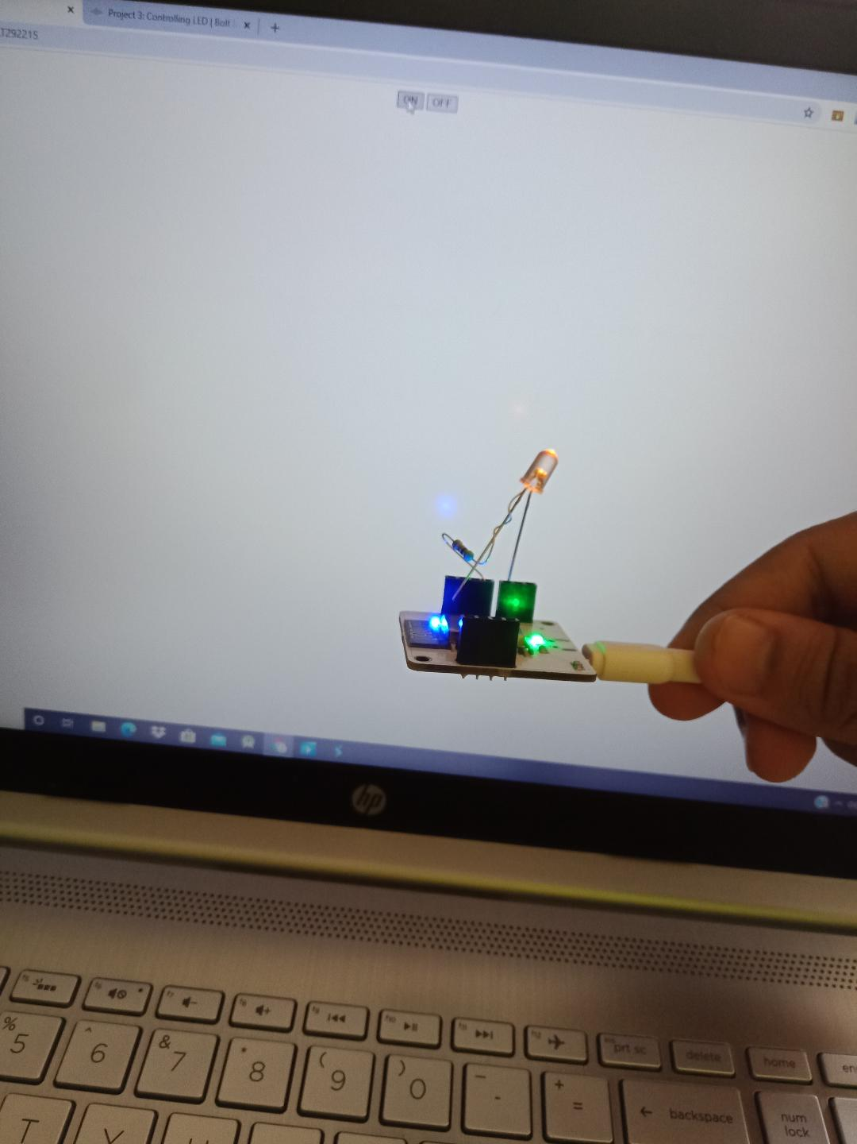

**LED Controller-OFF**

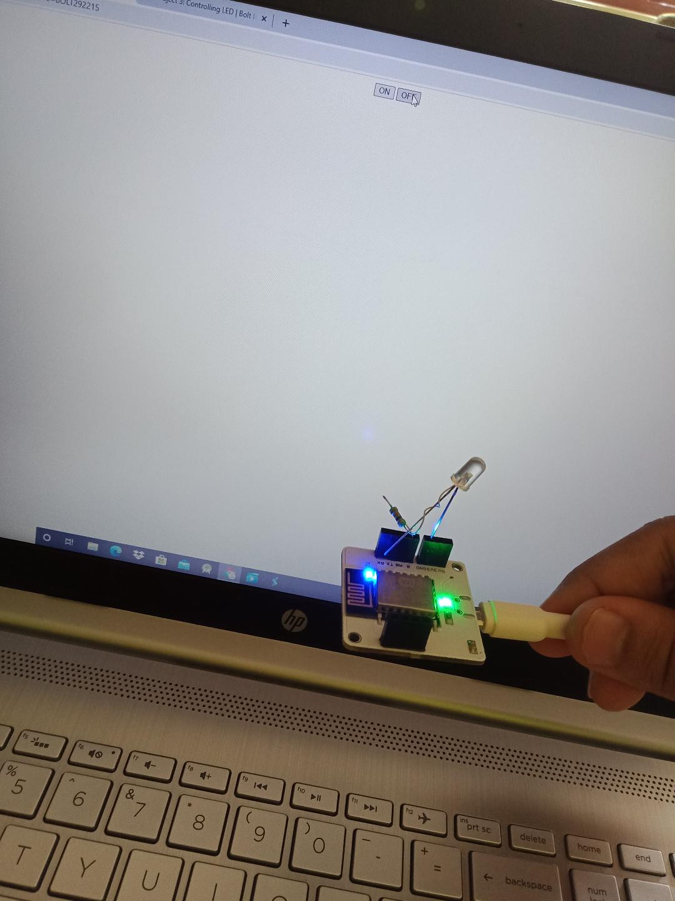

Credit-Rohan N Kalpavruksha